NURSING DIAGNOSIS
A nursing diagnosis is a clinical judgment concerning a human response to health conditions/life processes, or a vulnerability to that response, by an individual, family, group, or community. A nursing diagnosis provides the basis for selecting nursing interventions to achieve outcomes for which the nurse has accountability. Nursing diagnoses are developed based on data obtained during the nursing assessment and enable the nurse to develop the care plan.

Purposes of Nursing Diagnosis
The purpose of the nursing diagnosis is as follows:
- Helps identify nursing priorities and helps direct nursing interventions based on identified priorities.
- Helps the formulation of expected outcomes for quality assurance requirements of third-party payers.
- Nursing diagnoses help identify how a client or group responds to actual or potential health and life processes and knowing their available resources of strengths that can be drawn upon to prevent or resolve problems.
- Provides a common language and forms a basis for communication and understanding between nursing professionals and the healthcare team.
- Provides a basis of evaluation to determine if nursing care was beneficial to the client and cost-effective.
- For nursing students, nursing diagnoses are an effective teaching tool to help sharpen their problem-solving and critical thinking skills.

Differentiating Nursing Diagnoses, Medical Diagnoses, and Collaborative Problems
The term nursing diagnosis is associated with three different concepts. It may refer to the distinct second step in the nursing process, diagnosis. Also, nursing diagnosis applies to the label when nurses assign meaning to collected data appropriately labeled with NANDA-I-approved nursing diagnosis. For example, during the assessment, the nurse may recognize that the client feels anxious, fearful, and finds it difficult to sleep. Those problems are labeled with nursing diagnoses: respectively, Anxiety, Fear, and Disturbed Sleep Pattern. Lastly, a nursing diagnosis refers to one of many diagnoses in the classification system established and approved by NANDA. In this context, a nursing diagnosis is based upon the patient’s response to the medical condition. It is called a ‘nursing diagnosis’ because these are matters that hold a distinct and precise action associated with what nurses have the autonomy to take action about with a specific disease or condition. This includes anything that is a physical, mental, and spiritual type of response. Hence, a nursing diagnosis is focused on care.
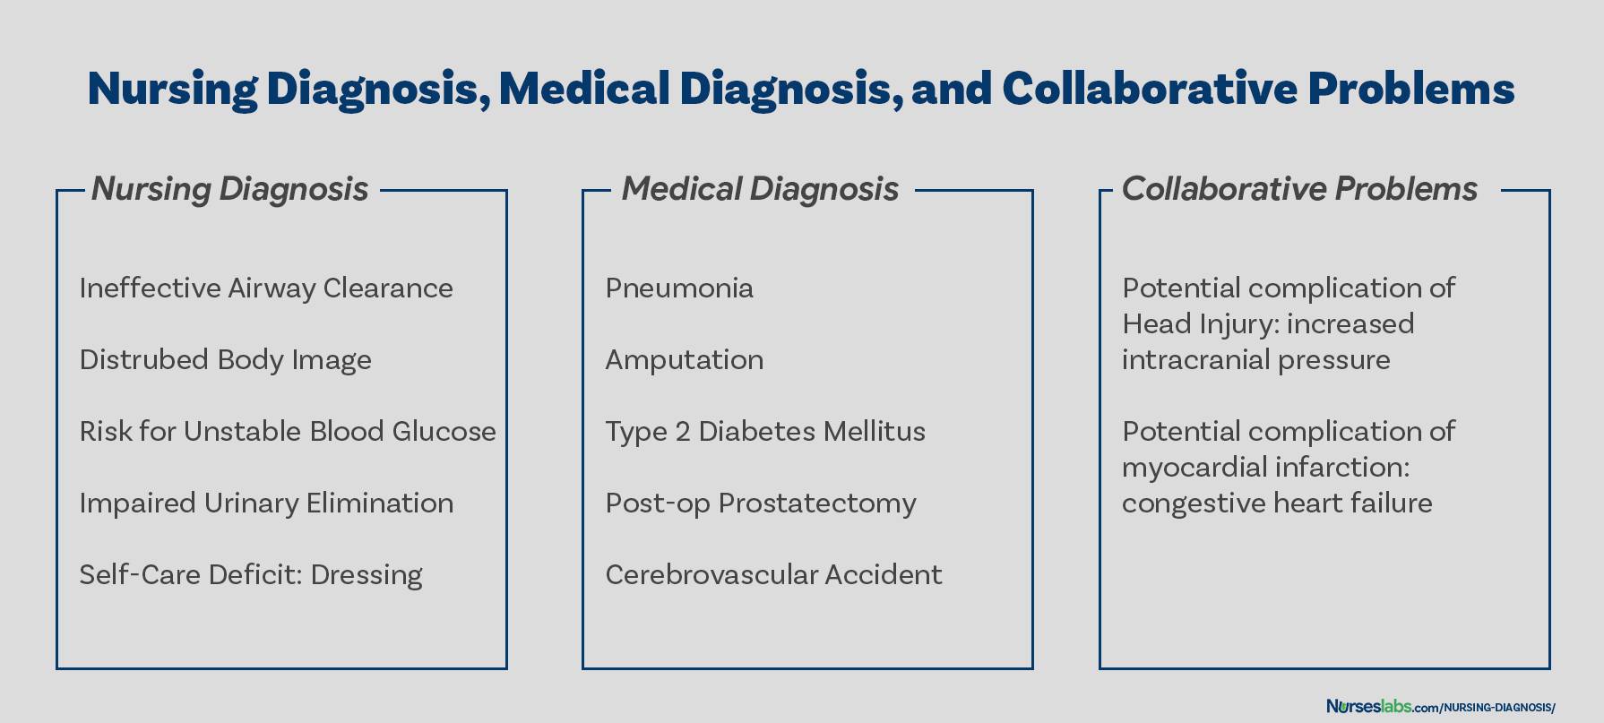COMPARED. Nursing diagnoses vs medical diagnoses vs collaborative problems

On the other hand, a medical diagnosis is made by the physician or advanced health care practitioner that deals more with the disease, medical condition, or pathological state only a practitioner can treat. Moreover, through experience and know-how, the specific and precise clinical entity that might be the possible cause of the illness will then be undertaken by the doctor, therefore, providing the proper medication that would cure the illness. Examples of medical diagnoses are Diabetes Mellitus, Tuberculosis, Amputation, Hepatitis, and Chronic Kidney Disease. The medical diagnosis normally does not change. Nurses must follow the physician’s orders and carry out prescribed treatments and therapies.
Collaborative problems are potential problems that nurses manage using both independent and physician-prescribed interventions. These are problems or conditions that require both medical and nursing interventions, with the nursing aspect focused on monitoring the client’s condition and preventing the development of the potential complication.
As explained above, now it is easier to distinguish a nursing diagnosis from a medical diagnosis. Nursing diagnosis is directed towards the patient and his physiological and psychological response. On the other hand, a medical diagnosis is particular to the disease or medical condition. Its center is on the illness.

NANDA International (NANDA-I)
NANDA-International, earlier known as the North American Nursing Diagnosis Association (NANDA), is the principal organization for defining, distributing and integrating standardized nursing diagnoses worldwide.
The term nursing diagnosis was first mentioned in the nursing literature in the 1950s. Two faculty members of Saint Louis University, Kristine Gebbie and Mary Ann Lavin recognized the need to identify nurses’ roles in an ambulatory care setting. In 1973, NANDA’s first national conference was held to identify, develop, and classify nursing diagnoses formally. Subsequent national conferences occurred in 1975, 1980, and every two years. In recognition of the participation of nurses in the United States and Canada, in 1982, the group accepted the name North American Nursing Diagnosis Association (NANDA).
n 2002, NANDA became NANDA International (NANDA-I) in response to its significant growth in membership outside of North America. The acronym NANDA was retained in the name because of its recognition.
Review, refinement, and research of diagnostic labels continue as new and modified labels are discussed at each biennial conference. Nurses can submit diagnoses to the Diagnostic Review Committee for review. The NANDA-I board of directors gives the final approval for incorporating the diagnosis into the official list of labels. As of 2021, NANDA-I has approved 267 diagnoses for clinical use, testing, and refinement.

History and Evolution of Nursing Diagnosis
In this section, we’ll look at the events that led to the evolution of nursing diagnosis today:
- The need for nursing to earn its professional status, the increasing use of computers in hospitals for accreditation documentation, and the demand for a standardized language from nurses led to the development of nursing diagnosis.
- Post-World War II, America saw an increase in nurses returning from military service. These nurses were highly skilled in treating medical diagnoses with physicians. Returning to peacetime practice, nurses were faced with renewed domination by physicians and social pressures to return to traditionally defined female roles with reduced status to make room in the workforce for returning male soldiers. Nurses felt increased pressure to redefine their unique status and value.
- The nursing diagnosis was seen as the approach that could provide the “frame of reference from which nurses could determine what to do and what to expect” in a clinical practice situation.
- Nursing diagnoses were also intended to define nursing’s unique boundaries concerning medical diagnoses. For NANDA, the standardization of nursing language through nursing diagnosis was the first step toward having insurance companies pay nurses directly for their care.
- In 1953, Virginia Fry and R. Louise McManus introduced the discipline-specific term “nursing diagnosis” to describe a step necessary in developing a nursing care plan.
- In 1972, the New York State Nurse Practice Act identified diagnosing as part of the legal domain of professional nursing. The Act was the first legislative recognition of nursing’s independent role and diagnostic function.
- In 1973, the development of nursing diagnosis formally began when two faculty members of Saint Louis University, Kristine Gebbie and Mary Ann Lavin, perceived a need to identify nurses’ roles in ambulatory care settings. The first national conference to identify nursing diagnoses was sponsored by the Saint Louis University School of Nursing and Allied Health Profession in the same year.
- Also, in 1973, the American Nurses Association’s Standards of Practice included diagnosing as a function of professional nursing. Diagnosing was subsequently incorporated into the component of the nursing process. The nursing process was used to standardize and define the concept of nursing care, hoping that it would help earn professional status.
- In 1980, the American Nurses Association (ANA) Social Policy Statement defined nursing as: “the diagnosis and treatment of human response to actual or potential health problems.”
- International recognition of the conferences and the development of nursing diagnosis came with the First Canadian Conference in Toronto (1977) and the International Nursing Conference (1987) in Alberta, Canada.
- In 1982, the conference group accepted the name “North American Nursing Diagnosis Association (NANDA)” to recognize the participation and contribution of nurses in the United States and Canada. In the same year, the newly formed NANDA used Sr. Callista Roy’s “nine patterns of unitary man” as an organizing principle since the first taxonomy listed nursing diagnosis alphabetically – which was deemed unscientific.
- In 1984, NANDA renamed “patterns of unitary man” as “human response patterns” based on the work of Marjorie Gordon. Currently, the taxonomy is now called Taxonomy II.
- In 1990 during the 9th conference of NANDA, the group approved an official definition of nursing diagnosis:
“Nursing diagnosis is a clinical judgment about individual, family, or community responses to actual or potential health problems/life processes. Nursing diagnosis provides the basis for selection of nursing interventions to achieve outcomes for which the nurse is accountable.”
- In 1997, NANDA changed the name of its official journal from “Nursing Diagnosis” to “Nursing Diagnosis: The International Journal of Nursing Terminologies and Classifications.”
- In 2002, NANDA changed its name to NANDA International (NANDA-I) to further reflect the worldwide interest in nursing diagnosis. In the same year, Taxonomy II was released based on the revised version of Gordon’s Functional health patterns.
- As of 2018, NANDA-I has approved 244 diagnoses for clinical use, testing, and refinement.
- As of 2021, there are 267 approved diagnoses for clinical use, testing, and refinement.

Classification of Nursing Diagnoses (Taxonomy II)
How are nursing diagnoses listed, arranged, or classified? In 2002, Taxonomy II was adopted, which was based on the Functional Health Patterns assessment framework of Dr. Mary Joy Gordon. Taxonomy II has three levels: Domains (13), Classes (47), and nursing diagnoses. Nursing diagnoses are no longer grouped by Gordon’s patterns but coded according to seven axes: diagnostic concept, time, unit of care, age, health status, descriptor, and topology. In addition, diagnoses are now listed alphabetically by their concept, not by the first word.
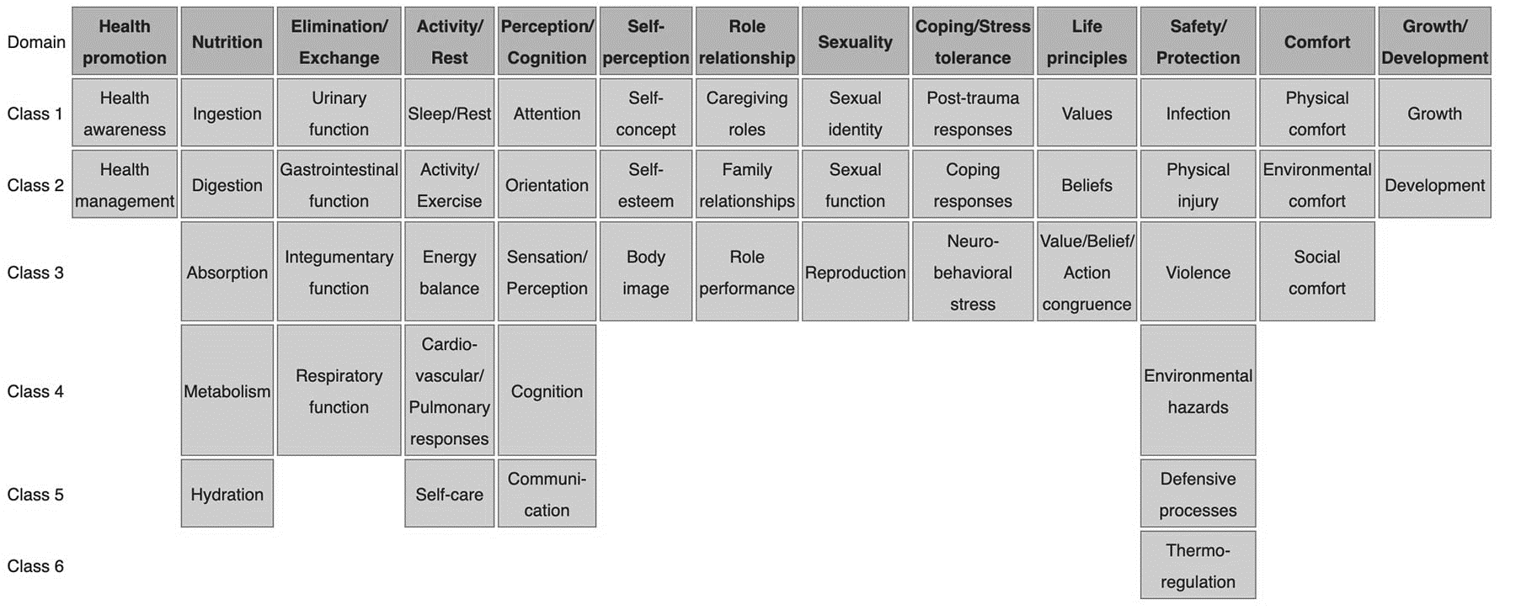NURSING DIAGNOSIS TAXONOMY II. Taxonomy II for nursing diagnosis contains 13 domains and 47 classes. Image via: Wikipedia.com
- Domain 1. Health Promotion
  - Class 1. Health Awareness
  - Class 2. Health Management
- Domain 2. Nutrition
  - Class 1. Ingestion
  - Class 2. Digestion
  - Class 3. Absorption
  - Class 4. Metabolism
  - Class 5. Hydration
- Domain 3. Elimination and Exchange
  - Class 1. Urinary function
  - Class 2. Gastrointestinal function
  - Class 3. Integumentary function
  - Class 4. Respiratory function
- Domain 4. Activity/Rest
  - Class 1. Sleep/Rest
  - Class 2. Activity/Exercise
  - Class 3. Energy balance
  - Class 4. Cardiovascular/Pulmonary responses
  - Class 5. Self-care
- Domain 5. Perception/Cognition
  - Class 1. Attention
  - Class 2. Orientation
  - Class 3. Sensation/Perception
  - Class 4. Cognition
  - Class 5. Communication
- Domain 6. Self-Perception
  - Class 1. Self-concept
  - Class 2. Self-esteem
  - Class 3. Body image
- Domain 7. Role relationship
  - Class 1. Caregiving roles
  - Class 2. Family relationships
  - Class 3. Role performance
- Domain 8. Sexuality
  - Class 1. Sexual identity
  - Class 2. Sexual function
  - Class 3. Reproduction
- Domain 9. Coping/stress tolerance
  - Class 1. Post-trauma responses
  - Class 2. Coping responses
  - Class 3. Neurobehavioral stress
- Domain 10. Life principles
  - Class 1. Values
  - Class 2. Beliefs
  - Class 3. Value/Belief/Action congruence
- Domain 11. Safety/Protection
  - Class 1. Infection
  - Class 2. Physical injury
  - Class 3. Violence
  - Class 4. Environmental hazards
  - Class 5. Defensive processes
  - Class 6. Thermoregulation
- Domain 12. Comfort
  - Class 1. Physical comfort
  - Class 2. Environmental comfort
  - Class 3. Social comfort
- Domain 13. Growth/Development
  - Class 1. Growth
  - Class 2. Development

Nursing Process
The five stages of the nursing process are assessment, diagnosing, planning, implementation, and evaluation. All steps in the nursing process require critical thinking by the nurse. Apart from understanding nursing diagnoses and their definitions, the nurse promotes awareness of defining characteristics and behaviors of the diagnoses, related factors to the selected nursing diagnoses, and the interventions suited for treating the diagnoses.

Types of Nursing Diagnoses
The four types of NANDA-I nursing diagnosis are Actual (Problem-Focused), Risk, Health Promotion, and Syndrome. Here are the four categories of nursing diagnoses provided by the NANDA-I system.

Problem-Focused Nursing Diagnosis
A problem-focused diagnosis (also known as actual diagnosis) is a client problem present at the time of the nursing assessment. These diagnoses are based on the presence of associated signs and symptoms. Actual nursing diagnosis should not be viewed as more important than risk diagnoses. There are many instances where a risk diagnosis can be the diagnosis with the highest priority for a patient.
Problem-focused nursing diagnoses have three components: (1) nursing diagnosis, (2) related factors, and (3) defining characteristics. Examples of actual nursing diagnoses are:
- Ineffective Breathing Pattern related to pain as evidenced by pursed-lip breathing, reports of pain during inhalation, use of accessory muscles to breathe
- Anxiety related to stress as evidenced by increased tension, apprehension, and expression of concern regarding upcoming surgery
- Acute Pain related to decreased myocardial flow as evidenced by grimacing, expression of pain, guarding behavior.
- Impaired Skin Integrity related to pressure over bony prominence as evidenced by pain, bleeding, redness, wound drainage.

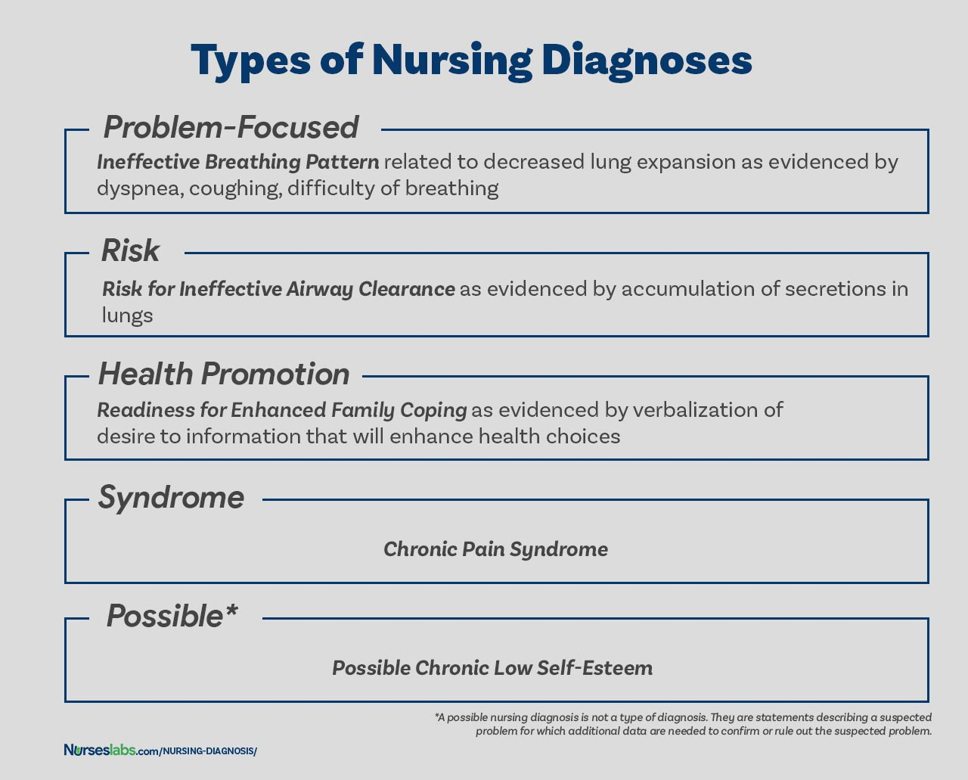TYPES OF NURSING DIAGNOSES. The four types of nursing diagnosis are Actual (Problem-Focused), Risk, Health Promotion, and Syndrome.

Risk Nursing Diagnosis
The second type of nursing diagnosis is called risk nursing diagnosis. These are clinical judgments that a problem does not exist, but the presence of risk factors indicates that a problem is likely to develop unless nurses intervene. There are no etiological factors (related factors) for risk diagnoses. The individual (or group) is more susceptible to developing the problem than others in the same or a similar situation because of risk factors. For example, an elderly client with diabetes and vertigo who has difficulty walking refuses to ask for assistance during ambulation may be appropriately diagnosed with Risk for Injury.
Components of a risk nursing diagnosis include (1) risk diagnostic label, and (2) risk factors. Examples of risk nursing diagnosis are:
- Risk for Falls as evidenced by muscle weakness
- Risk for Injury as evidenced by altered mobility
- Risk for Infection as evidenced by immunosuppression

Health Promotion Diagnosis
Health promotion diagnosis (also known as wellness diagnosis) is a clinical judgment about motivation and desire to increase well-being. Health promotion diagnosis is concerned with the individual, family, or community transition from a specific level of wellness to a higher level of wellness. Components of a health promotion diagnosis generally include only the diagnostic label or a one-part statement. Examples of health promotion diagnosis:
- Readiness for Enhanced Spiritual Well Being
- Readiness for Enhanced Family Coping
- Readiness for Enhanced Parenting

Syndrome Diagnosis
A syndrome diagnosis is a clinical judgment concerning a cluster of problem or risk nursing diagnoses that are predicted to present because of a certain situation or event. They, too, are written as a one-part statement requiring only the diagnostic label. Examples of a syndrome nursing diagnosis are:
- Chronic Pain Syndrome
- Post-trauma Syndrome
- Frail Elderly Syndrome

Possible Nursing Diagnosis
A possible nursing diagnosis is not a type of diagnosis as are actual, risk, health promotion, and syndrome. Possible nursing diagnoses are statements describing a suspected problem for which additional data are needed to confirm or rule out the suspected problem. It provides the nurse with the ability to communicate with other nurses that a diagnosis may be present but additional data collection is indicated to rule out or confirm the diagnosis. Examples include:
- Possible Chronic Low Self-Esteem
- Possible Social Isolation.

Components of a Nursing Diagnosis
A nursing diagnosis has typically three components: (1) the problem and its definition, (2) the etiology, and (3) the defining characteristics or risk factors (for risk diagnosis).
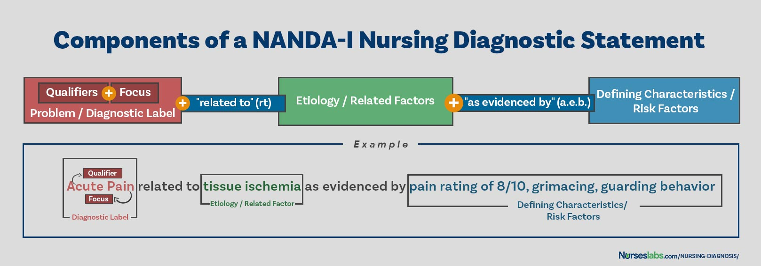BUILDING BLOCKS OF A DIAGNOSTIC STATEMENT. Components of an NDx may include problem, etiology, risk factors, and defining characteristics.

Problem and Definition
The problem statement, or the diagnostic label, describes the client’s health problem or response to which nursing therapy is given concisely. A diagnostic label usually has two parts: qualifier and focus of the diagnosis. Qualifiers (also called modifiers) are words that have been added to some diagnostic labels to give additional meaning, limit, or specify the diagnostic statement. Exempted in this rule are one-word nursing diagnoses (e.g., Anxiety, Constipation, Diarrhea, Nausea, etc.) where their qualifier and focus are inherent in the one term.
Qualifier | Focus of the Diagnosis
Deficient | Fluid volume
Imbalanced | Nutrition: Less Than Body Requirements
Impaired | Gas Exchange
Ineffective | Tissue Perfusion
Risk for | Injury

Etiology
The etiology, or related factors, component of a nursing diagnosis label identifies one or more probable causes of the health problem, are the conditions involved in the development of the problem, gives direction to the required nursing therapy, and enables the nurse to individualize the client’s care. Nursing interventions should be aimed at etiological factors in order to remove the underlying cause of the nursing diagnosis. Etiology is linked with the problem statement with the phrase “related to” such as:
- Decreased activity tolerance related to generalized weakness.
- Impaired physical mobility related to imposed bed rest.

Risk Factors
Risk factors are used instead of etiological factors for risk nursing diagnosis. Risk factors are forces that put an individual (or group) at an increased vulnerability to an unhealthy condition. Risk factors are written following the phrase “as evidenced by” in the diagnostic statement.
- Risk for Falls as evidenced by old age and use of walker.
- Risk for Infection as evidenced by break in skin integrity.

Defining Characteristics
Defining characteristics are the clusters of signs and symptoms that indicate the presence of a particular diagnostic label. In actual nursing diagnoses, the defining characteristics are the identified signs and symptoms of the client. For risk nursing diagnosis, no signs and symptoms are present therefore the factors that cause the client to be more susceptible to the problem form the etiology of a risk nursing diagnosis. Defining characteristics are written following the phrase “as evidenced by” or “as manifested by” in the diagnostic statement.

Diagnostic Process: How to Diagnose
There are three phases during the diagnostic process: (1) data analysis, (2) identification of the client’s health problems, health risks, and strengths, and (3) formulation of diagnostic statements.

Analyzing Data
Analysis of data involves comparing patient data against standards, clustering the cues, and identifying gaps and inconsistencies.

Identifying Health Problems, Risks, and Strengths
In this decision-making step, after data analysis, the nurse and the client identify problems that support tentative actual, risk, and possible diagnoses. It involves determining whether a problem is a nursing diagnosis, medical diagnosis, or a collaborative problem. Also, at this stage, the nurse and the client identify the client’s strengths, resources, and abilities to cope.

Formulating Diagnostic Statements
Formulation of diagnostic statements is the last step of the diagnostic process wherein the nurse creates diagnostic statements. The process is detailed below.

How to Write a Nursing Diagnosis?
In writing nursing diagnostic statements, describe an individual’s health status and the factors that have contributed to the status. You do not need to include all types of diagnostic indicators. Writing diagnostic statements vary per type of nursing diagnosis (see below).
